User’s Manual

**Golden Dale’s Food Processing Corp.**

Lozano, Cielito Angelo

Garcia, Thomas Jullian R.

BSIT 3-5

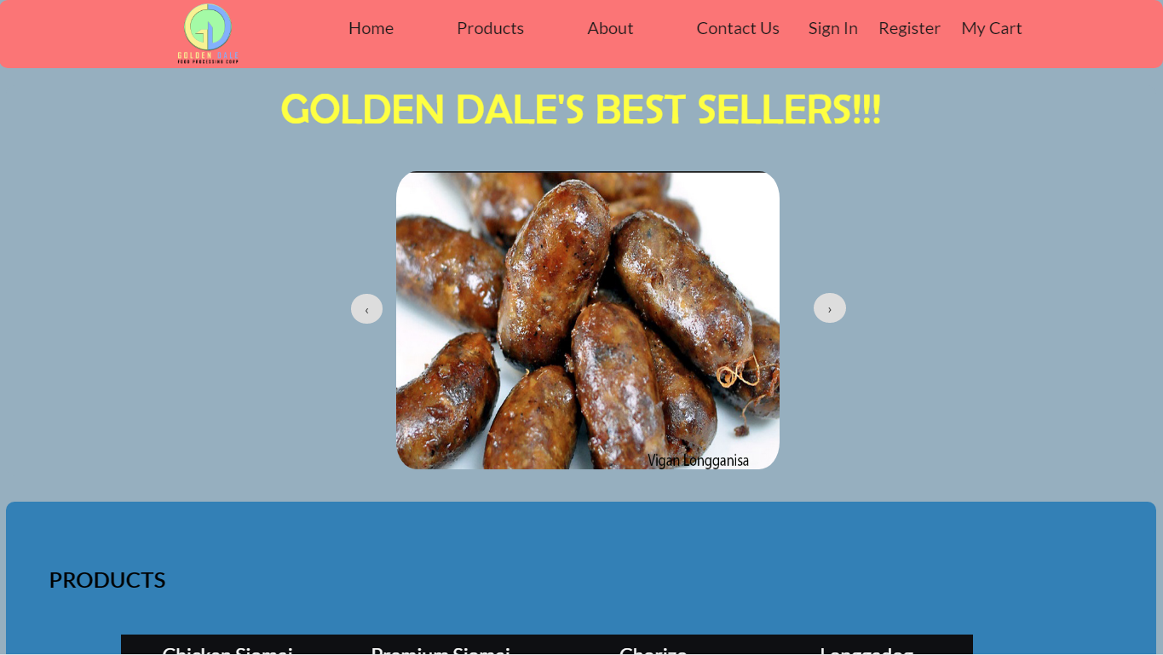

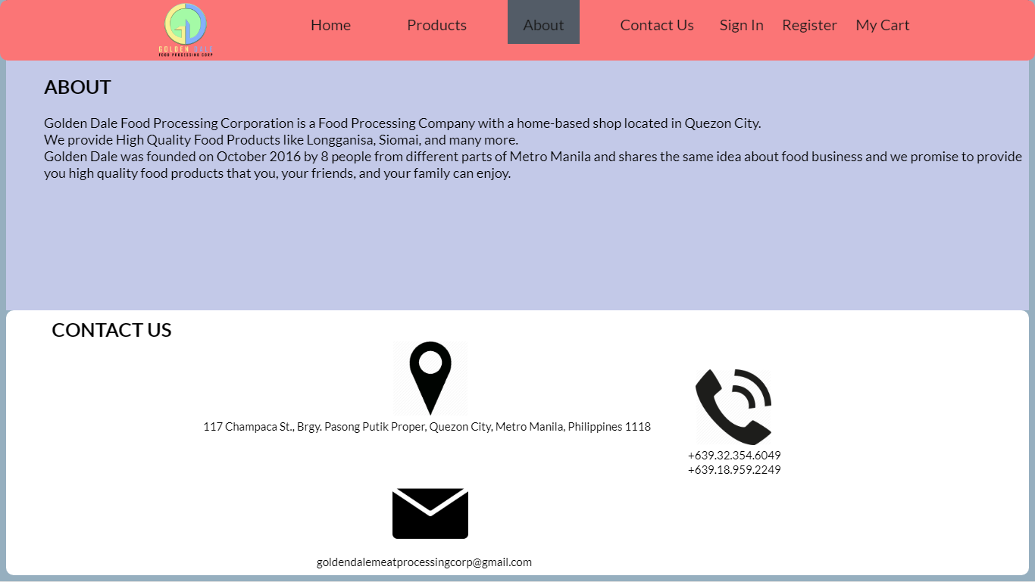 This is the landing page of the system, you can see the products by just scrolling down, you can also view the best seller products of Golden Dale. The landing page also contain the information about the Golden dale and their contact information.

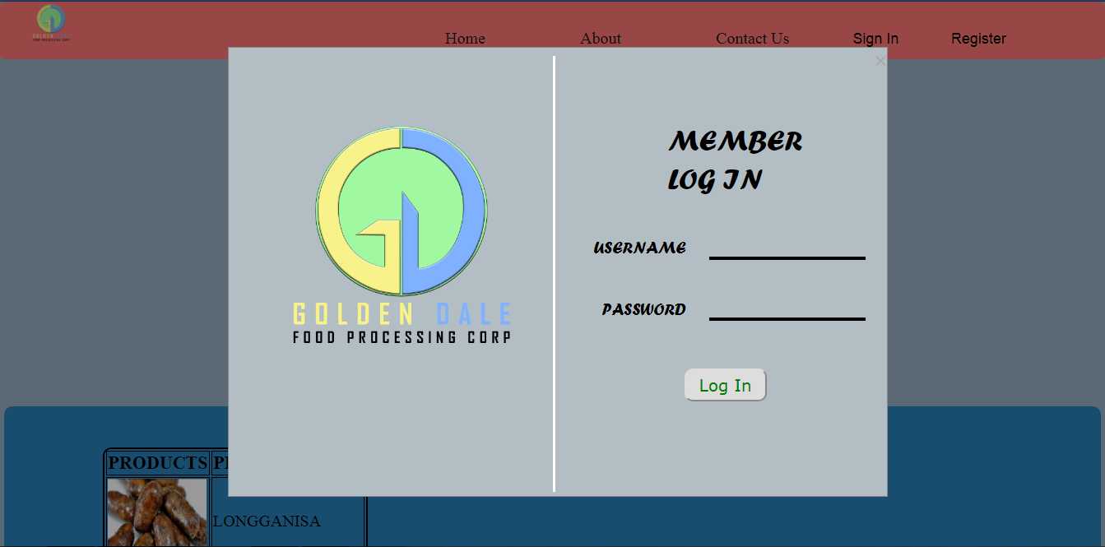

The user needs to log in first their account in able to buy products in the system.

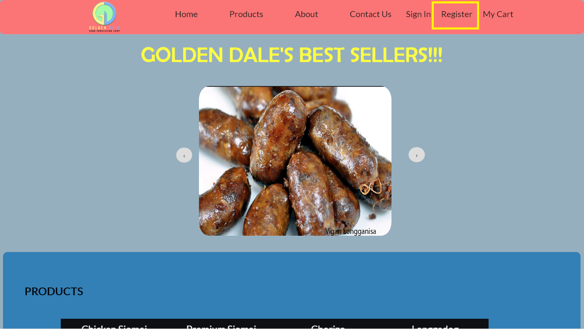If you don’t have an account you can create your account by just clicking the “Register” button at the upper right corner of the page.

After clicking the “Register” button, The Sign Up” modal will appear in the screen. The User just need to fill up the form and then click the Register button. An Alert will appear if the user is successfully registered.

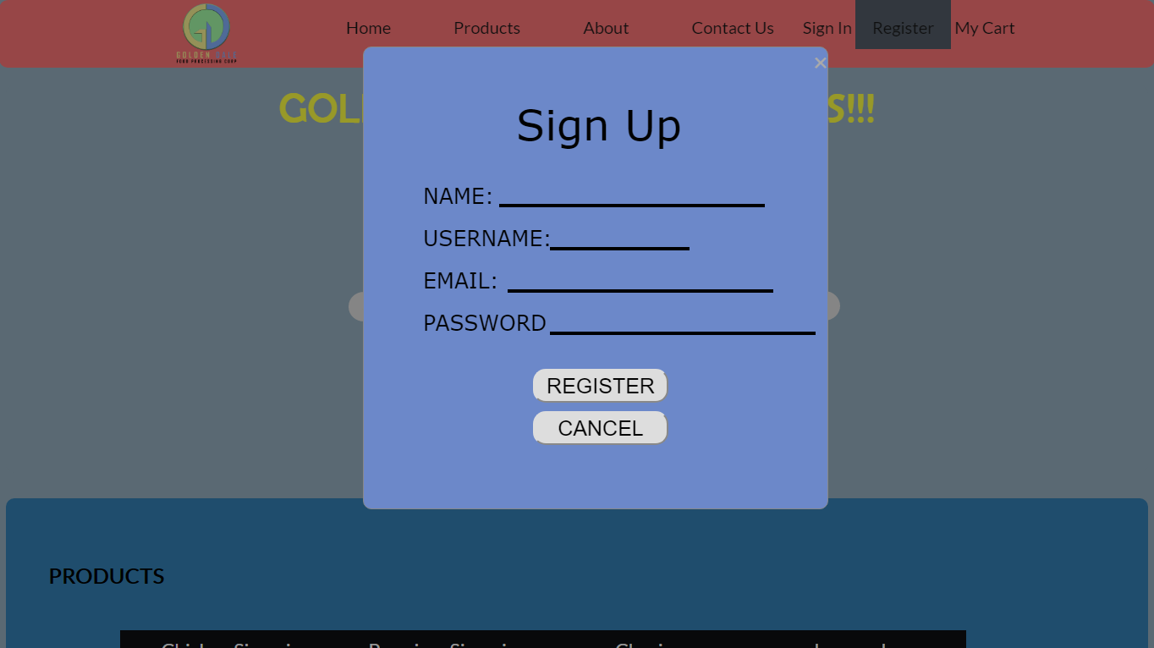

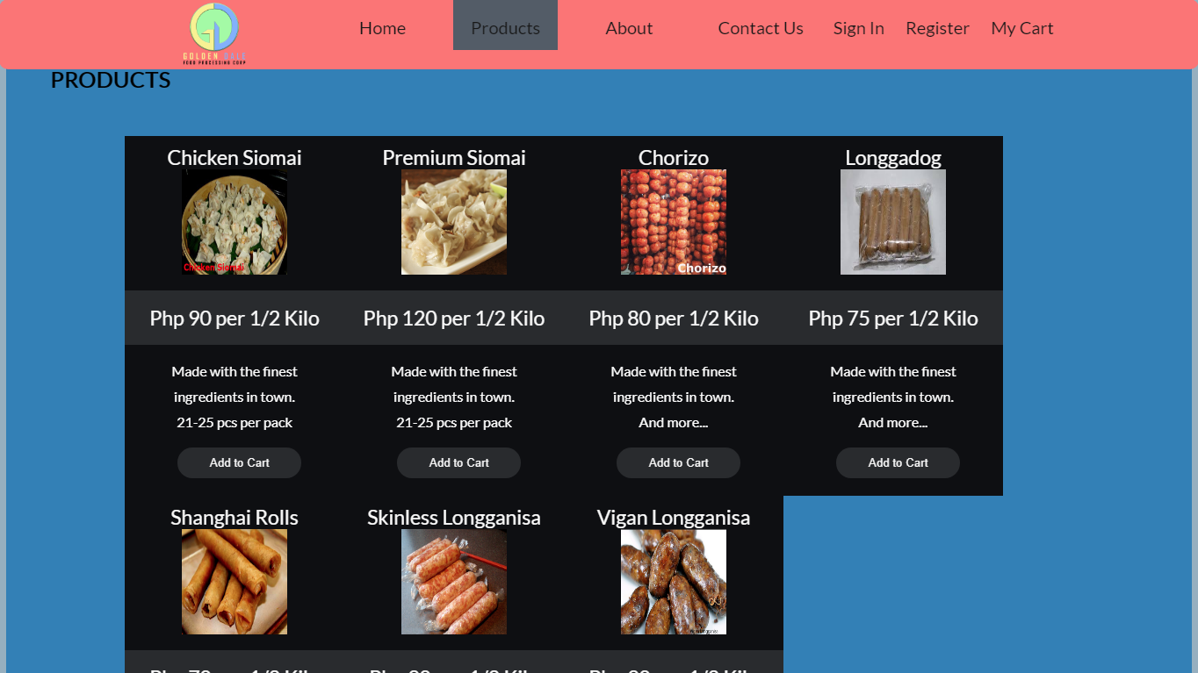After signing up, you can now select any product in the system. Just click the “Add to cart” button if you want to buy that food.

After you finish ordering, you can see the list of your order by just clicking the “My Cart” button at the upper right corner of the Landing Page.

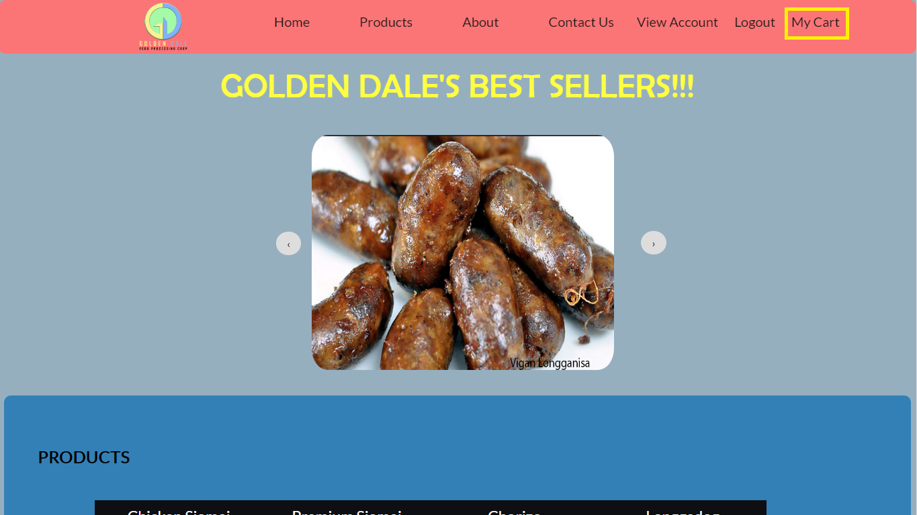

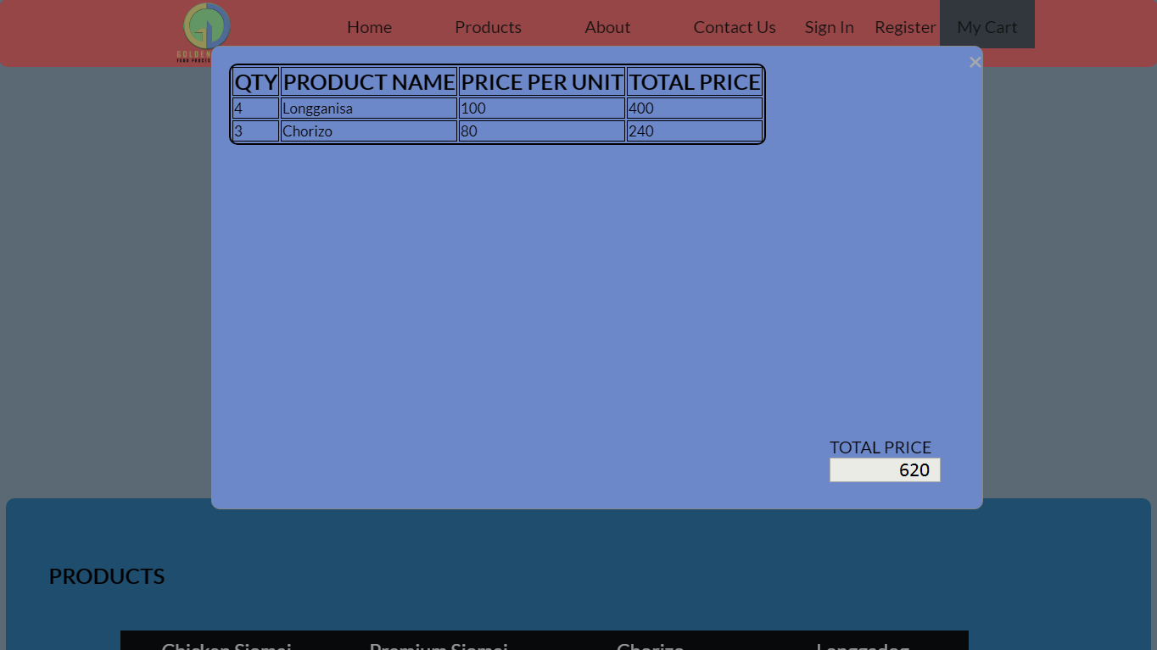Then, the Order modal will appear in your screen.